November 1972. I was to spend a week with Dr John Bowlby at the Tavistock Clinic in London. I was just entering my second year as a qualified social worker and at that time working in the Department of Child and Family Psychiatry in Fife, Scotland.
The meeting with Bowlby had been arranged by the consultant in charge of where I worked, Dr Douglas Haldane, and it was designed to focus on a possi- ble research project on the impact on infant development where mothers were physically present to their very young babies, but emotionally absent.
We had a small number of children at the time that seemed impossible to reach, who were emotionally completely detached and even at the age of five or six were attracting the label of being a “potential psychopath”. It was these chil- dren who were of concern to us and we wondered whether they were the prod- uct of some extreme lack of emotional connection between parent and child.
John Bowlby was known to our department but not to me personally at that time. I had read Bowlby’s original work and his recently published Volume I of his Attachment Trilogy (Bowlby, 1969). I had been reading the pamphlets from the Family Discussion Bureau at the Tavistock as an adolescent, so visit- ing the Tavistock and meeting with John Bowlby was a hugely exciting project. However, right into the centre of this emotionally charged state of mine came a phone call telling me that my mother was dying and that I should return home immediately. The news came the night before I was to leave for London.
I rang Dr Bowlby and we agreed that I would go home and if possible return in a few days time to spend one day with him in London. This I did. It was quite clear then that my mother was dying so this huge issue of my own very personal loss was to dominate my meeting with the man who had made separation and loss the dominant theme of his own research and clinical interest.
ATTACHMENT: New Directions in Psychotherapy and Relational Psychoanalysis, Vol. 7, July 2013: pp. 148–167.
ATTACHMENT 149
As he came to get me from the waiting room, my first impression of Bowlby was of a tall, gentle, and self-effacing man. It was not as terrifying an experi- ence as I had expected. I described the project that we were interested in ex- ploring and I remember him asking me if I had had any experience of observ- ing animals in their natural habitat. My only experience was of a very close association with a man who bred and trained gun dogs. Bowlby seemed to think that the observation of training animals at close quarters was a valuable education for understanding human growth and development.
I had decided to return home that evening from London, and as I was leav- ing, Bowlby and I both knew what I was facing. He got up from his chair and searched around and said “I’ve got something here that I’ve just written that I think might be helpful to you.” I read the article on the way home. It was entitled “Self-reliance and some conditions that promote it” (Bowlby, 1979).
In my precociously mature state at the time, which was full of fear and dread, I, of course, misinterpreted the message in this paper to mean that I should strive to be self-reliant and that that was the mature position. It has taken me many years to see what was actually in that paper and to discover it for myself, which is that the conditions that promote self-reliance are basically the avail- ability of a responsive, concerned, and empathic care-giver.
I have made the relationship between care-seeker and care-giver the focus of my own life study, not as originally planned with Bowlby, but on the care- giving provided by a therapist to the person seeking help and, by implication, all those who provide care for other people.
My title is “Fear Free Exploratory Care-giving: A Challenge for Therapists in the Present Social, Political, and Cultural Environment”. I present it as a chal- lenge, because I think the major developmental work for all of us—taking a life time—is to regulate our own fear system so that we can remain truly explo- rative care-givers when called upon to be so in our personal and professional relationships. It requires us to discover who we are and what we believe in and value, to discover what we know, and express it, stand up to the fear driven behaviour of other individuals, groups, and as a nation, other nations.
I started my own studies on the care-seeking–care-giving relationship in the context of therapeutic interventions, influenced by the work of many re- searchers on affect attunement, affect regulation, and the rhythms and patterns of communication between young infants and parents. These include the following: Ainsworth and Wittig (1969), Ainsworth, Bell, and Stayton (1974), Ainsworth, Blehar, Waters, and Wall (1978), Emde, (1983, 1985), Grossmann, Fremmer-Bombik, Rudolph, and Grossmann (1988), Grossmann, Grossmann, Spangler, Suess, and Unzner, (1985), Meltzoff, (1983), Meltzoff & Moore (1977), Murray (1998), Murray and Trevarthen (1985, 1986), Papousek, (1994), Papousek & Papousek (1979), Stern (1985), Tronick (1989), Tronick and Cohn (1989), Tronick, Als, and Brazelton (1977), and many others. In my own book, To be
Fear Free Exploratory Care-giving
150 ATTACHMENT
Met as a Person: the Dynamics of Attachment in Therapeutic Encounters (McCluskey, 2005), I conceptualised that implicit in the offer to treat someone therapeutically would elicit the dynamics of attachment. I suggested that it was the job of the therapist to monitor the many ways that the care-seeker was relat- ing to them and to adjust their own behaviour so that the care-seeker’s affect was properly regulated and they could communicate their concerns clearly.
The complicated process of affect attunement and regulation as a fundamen- tal element of assuaging care-seeking I termed “goal corrected empathic attune- ment” (GCEA). Goal corrected attunement is a highly interactive process between care-seeker and care-giver and it is this focus on interaction that is cen- tral to the therapeutic practice that I have developed (www.unamccluskey.com).
In this paper I want to focus on the enormous consequences for adults, particularly for adult care-givers, of having their own affect unregulated and their own care-seeking system unassuaged. Apart from the consequences for adult care-givers in their own lives, this lack of assuagement and an inability to notice or regulate their own arousal levels has a huge effect on whether care- givers can provide effective exploratory care for their clients.
Clients can threaten the well-being of therapists. We do not often talk about this fact. When this happens, the therapist’s own fear system is likely to be trig- gered, as is their attachment system, expressed through care-seeking. The ther- apist’s internal environment will be aroused and will be either supportive or unsupportive in regulating the therapist’s fear system. If their internal envi- ronment is supportive, it will remind them of their competence and enable them to take an exploratory stance towards the presentation of the care-seeker, perceived initially as a threat. If the therapist is not able to access an internal or external supportive environment then they are likely to move into a defen- sive response. When this takes the form of care-giving infiltrated by fear (defensive care-giving), it can have dire consequences for carer and cared for alike.
To help us examine the process that I am talking about: that of defensive care-giving in professional care-givers, I am going to draw on the situation within the Catholic Church in Ireland. I will also focus on what I am learning through working with a very large number of care-givers from a wide variety of professional backgrounds, where the focus has been on exploring their own dynamics of attachment and how it impacts on their work.
We are in fact talking about “fear-driven care-giving”—and whenever we have fear involved we have the dynamics of dominance vs. submission. We also know that when the fear system is active, exploration goes on hold.
Defensive care-giving is what a person may resort to when they are not met as a person, not seen as a person, their needs left unattended, left abandoned and alone, sometimes in terrible pain and distress, sometimes bored. When one’s needs are overridden by an adult care-giver it is usual for the adult to
Una McCluskey
ATTACHMENT 151
accompany their non verbal aggression, lack of response, or dismissiveness by some verbal attribution—most normally of a negative kind—”How could you be so demanding—can you not just leave me alone?”, “You are such a nuisance.” These attributions, as Dorothy Heard has pointed out, very often become core beliefs of the self and contribute to an unsupportive internal envi- ronment. So, it is possible that at the core of the unmet self we have a very harsh or vicious internal environment where the person may believe they are unwelcome in the world and not truly loved for his or her self.
What I am learning from my work with professional care-givers is that the validation one gets from defensive care-giving, and the positive attributions that accompany it, may help to assuage a deep loneliness in the self, a desire to be seen, a desire to be appreciated as a good person. But the validation achieved through this form of care-giving, tragically, does not support and strengthen the core of the vulnerable self. It is like a drug, the person requires constant access to another fix. This is why it can sometimes look to an outsider and be experienced by the person themselves as “compulsive care-giving”. Defensive care-giving can also support the process of excluding from consciousness, expe- riences, emotions, and attributions that are both painful to the self and unsup- portive of the self. To this extent, the person themselves may be in complete denial that they are in the grip of these dynamics. Their sense of themselves and their self-esteem may be boosted by belonging to a profession held in high social esteem.
When we move into defensive care-giving we lose our freedom, we have no degree of freedom other than to respond to the demands of the other. It is a process that is driven by fear consciously or otherwise. The consequences of not responding are not thought about, sometimes cannot be thought about, and the impact on others can be terrible.
From my recent work with care-givers, professional, lay, and religious, it seems to be that defensive care-giving has the potential to be sadistic and often is. It is because of this that I consider that we really do need to become aware of how to properly support those who take up care-giving positions in society.
The state of the Catholic Church in Ireland
I will start with my examination of the furore that went on in Ireland in response to two major reports published in 2009. The first was a report of the The Commission to Inquire into Child Abuse (2009), known as the Ryan Report, which investigated the situation for children in residential institutions run by religious congregations which reported in May 2009. The second was a Report by Commission of Investigation into the Catholic Archdiocese of Dublin (2009), known as the Murphy Report, which came out in November of
Fear Free Exploratory Care-giving
152 ATTACHMENT
the same year and which focused on a sample of forty-four priests in the Dublin diocese who had sexually abused children. Both these reports make for shocking reading. There have been further reports since then, but I am going to locate my analysis in the period when these two reports were published as the detail of what happened was readily available through the national news channels and the response from the Irish public was at its most intense.
The lead in to these and subsequent reports started in 1995 with the screening of a film called Dear Daughter (Lentin, 1995) that was based on the life story of a young woman who was brought up in an orphanage, near Dublin, run by a religious order of women. This was followed in 1998, by the broadcast of a tele- vision documentary Sex in a Cold Climate (Humphries, 1998), that documented the plight of young women who were sent to a religious institution because they were seen to be potentially promiscuous or had become pregnant out of wed- lock. The plight of these women, known as “The Magdalene” after the name of the laundries they worked in, has recently hit the national and international press again (McDonald, 2013, The Guardian). The programme provoked an out- cry in Ireland and in England. Helplines were jammed. People who had either been in such institutions or who had witnessed sadistic behaviour and emo- tional abuse perpetrated by religious care-givers, phoned in.
In 1999 an Irish journalist, Mary Raftery (1999), directed a three part docu- mentary that was broadcast on Irish television entitled States of Fear. This pro- gramme dealt with the industrial schools run by religious orders and funded by the state to look after children in need of care. The programme triggered an apology from the prime minister at the time, because of the State’s complicity in financially supporting the religious orders to run institutions for children and which had failed to monitor and regulate the standards of care offered.
That same year, the Laffoy Commission was established to look into what had happened in these institutions. Three years later Justice Laffoy resigned as chairman of the commission due to lack of proper support from the Government. The commission was then chaired by Justice Ryan who encoun- tered further problems from the Christian Brothers, a male order of religious who were one of the primary providers of care and, it turns out, one of the orders involved in abuse, particularly sexual abuse of boys. Eventually it was able to go about its business by giving a right of protection to the religious orders. Nobody named by survivors would have their name appear in public. The Ryan Commission produced its 2,200 page report in May 2009. Nobody was prepared for what happened next.
The religious orders, eighteen of whom were identified as the chief perpe- trators of abuse, had signed a deal with the Government some years previously protecting them from any further financial liability.
The first week after publication of the Ryan Report the religious orders stuck to their view that it was unnecessary to re-visit that financial agreement and no
Una McCluskey
ATTACHMENT 153
further money would be forthcoming. The Government and the religious orders were unprepared for the public response. It was as if the whole country rose up in shock and outrage at the volume of documented abuse.
For the rest of 2009 and most of 2010 there were nearly continuous phone-ins to the radio, regular television programmes, and several pages of the Irish Times were devoted, on a daily basis, to the scandals within the church. In early 2010 there was a call for the resignation of Cardinal Brady. This was closely followed by the Pope accepting the resignation of Bishop McGee for his failure to use proper child protection procedures in relation to the rape of chil- dren by priests in his diocese.
The facts presented in the Ryan Report (2009), show that 25,000 children were committed to residential institutions run by religious orders between 1937 and 1978. While the commission was sitting 17,774 adults contacted a Health Service Executive Counselling Service for help. Ninety per cent of those who appeared before the Ryan Committee claimed they were physically abused, fifty per cent claimed they were sexually abused, fifty per cent were under five when first committed to industrial schools, and another extraordinary and tragic fact is that children spent an average of nine years in such schools. Sexual abuse was endemic in boys’ institutions.
The following are some quotes from those interviewed by the Ryan Commission on their experiences in the residential institutions:
Stripped naked, flogged
Forced oral sex and beatings
Taken from bed and made to walk round naked in front of other boys whilst
Brothers used their canes and flicked at their penis Tied to a bed and physically abused by three carers Starvation—watching pets and animals being fed Locked in room with rats
Left to sleep with the pigs
The emotional removal of self—it still has consequences
I could stand the beatings—the worst thing was the mental abuse.
(Ryan Report, 2009, pp. 113–119)
Number eleven of the conclusions in the executive summary of the Ryan Report captures the emotional experience of children living with the daily terror of not knowing where the next beating was coming from,
A climate of fear, created by pervasive, excessive and arbitrary punishment, permeated most of the institutions and all those run for boys. Children lived with the daily terror of not knowing where the next beating was coming from.
It is my view that the unremitting outrage of Irish people and their reluc- tance to stop hounding the church is based on:
Fear Free Exploratory Care-giving
154 ATTACHMENT
. (a) The response of the church in Ireland, which still fails to respond with empathic attunement to those they have abused and to the Irish people whom they have betrayed.
- (b) The response of the Vatican, which attempted to deal with this crisis as particular to Ireland—an Irish problem.
It does not take much imagination or insight to see these responses for what they are—defensive, lacking compassion and care, and acting on an impulse to target and scapegoat.
They are fear driven responses and the people are outraged.
Second, I think the response is fuelled by the actual volume of people whose lives have been touched by this abuse, either as victims or observers, and the number of people who may well have been abused within their own families but have not been able to talk about it but are finding the drama going on in the church an opportunity to explore and vent their own experience. This is coupled with a fury with all the institutions, state, and church, who they feel have lied to them and let them down.
The religious themselves represented a fairly good cross section of Irish soci- ety, in terms of social background, educational experiences, and emotional maturity or lack of it.
But there was one important difference between religious institutional life and ordinary society that made it even more difficult, I think, for those within the institutions to speak out if they disagreed with what they saw and heard. They had joined, in Goffman’s (1961) terms, total institutions. They lost their name, they wore a uniform, they had no personal possessions, and they had to ask permission for everything they needed. In other words there was a strict line of authority. They were required to manage interpersonal difficulties on their own. They were forbidden close friendship. Touching other people was forbid- den and up until the Vatican council in the early 1960s some orders engaged in a practice known as mortification of the flesh. In other words, self-inflicted physical pain was approved of as a way of dealing with desire, thus leading to an emphasis on self-containment as a way of solving an interpersonal problem.
There was an over-emphasis on the survival of the institution and the work to be achieved, often good work, combined with a complete lack of attention to the individuals who were providing the work necessary for all this. There was a denial that the religious themselves had any personal needs and if they were distressed or in pain they were encouraged to direct their attention to God in the form of prayer. They were encouraged to “spiritualise” their problems.
I have been working with religious for many years now and have had a number in the attachment groups that I referred to earlier.
What is noteworthy is the lack of self-narrative, a thinness of recall of child- hood memories, an over reliance on humour when talking about tragic and
Una McCluskey
ATTACHMENT 155
painful situations they have experienced in the novitiate, an over idealisation of parents and an inability to criticise them, an inability to say “no”, an inabil- ity to deal constructively with frustration and anger in relationships, fears of being bullied by other people, and an inability to see they might have a tendency to dominate the other themselves. It is hard to explain the lack of self- narrative, other than to think that an overemphasis on “service” and a culture that frowned on what was erroneously seen as “ego” may have contributed, for some, to a lack of attention to their own development as a person.
The dominant system active within some individuals, faced by the over- whelming demands in many of these institutions, was the system for self- defence. From what I have said earlier, this is likely to have been expressed through the fear system, and while the care-seeking system would, of course, be activated, most were too afraid to go anywhere for help.
There were many religious who had a deep compassion for those in their care but most of these men and women presumably tried to sort the problem at an individual level rather than at an institutional level.
The situation with religious in Ireland now is that many of them feel very ashamed about these revelations, actions that were carried out by a minority of their members. They feel frightened to go out into the public arena, they feel frightened about wearing anything that would identify them as religious, and they have been the target of abuse and vitriol from the public. Many of them feel let down by the institutional church of which they are members but partic- ularly by their male colleagues in the diocesan clergy who sided against them after the publication of the Ryan report and who insisted they hand over more money to the State for redress. Many have a deep spiritual awareness and commitment, and may deviate in their views and opinions from the canonical church and the current practices and behaviour of their colleagues, but on the whole these people are silent—they do not speak out in public, and that is really tragic as their voice is lost and possibly lost for ever, as they are all getting old and the congregations they belong to seem to be dying out, at least in the western world.
But these residential institutions did not exist in a vacuum. They were regu- larly visited by members of the medical profession, there were State inspec- tions and monitoring. In addition, the level of emotional and physical abuse was known to the public who overheard it on the streets, who had experienced it or witnessed it themselves or whose children came home from schools in tears at what they were witnessing. So we are talking about a national event where various groups of people—lay, religious, and professional at all levels of society and Government conspired to allow the neglect and abuse of children. I have written elsewhere about the dynamics of this (McCluskey, 2000).
I will now focus on defensive care-giving and the way in which the fear system can evacuate from consciousness trauma in the self and the observed
Fear Free Exploratory Care-giving
156 ATTACHMENT
trauma of others. We are talking here about the results of a failure in the provi- sion of an effective and fear free exploratory care-giving relationship. Instead we have care being offered by people who were frightened themselves. People whose own fear system was not properly assuaged in childhood, and when activated in adulthood can leave them with no awareness of feeling fear and certainly no awareness that help could be available. They are then left at the mercy of the reflex response to the activation of the fear system—dominance, dismissiveness, freeze, withdrawal.
What was going on in the case of institutions run by religious was that we had a combination of a lack of self-development, compulsive care-giving driven by the highest of aspirations, as well as a lack of capacity for some reli- gious to integrate the pain of their own failed care-seeking from their original care-giver. It was this mixture of dynamics within individuals, compounded by a group culture that was hierarchically organised and controlled by fear, nested in a wider society that used public shame and humiliation as a form of control- ling anyone who deviated from church law or church mores, that made it almost impossible for witnesses of abuse and abusive situations to take any positive action. Just as the “whistle blowers” of today are only now getting legal protection for their actions, whistle blowers of the past would know they could not reliably predict a positive supportive response from their superiors.
The dreaded days of institutional abuse are not behind us. The unbridled sadistic assault of vulnerable people is not locked up in Catholic Ireland. We have many examples of out of control care staff abusing our elderly people in residential homes. In the UK, child asylum seekers are more often seen by the various authorities charged with looking after children as migrants first rather than children, leading to serious concerns about their care and well-being (see the latest report from the Refugee Council, 2013).
The theoretical contribution to our understanding of the self provided by the work of Dr Dorothy Heard and the late Dr Brian Lake
While Bowlby and subsequent researchers found an association between early loss and trauma and adult mental health, to my mind there has not been a theory that could express the dynamic intra and inter personal processes that might contribute to this happening. This gap has been filled by the work of Dorothy Heard and Brian Lake. Brian and Dorothy give a coherent account of how it comes about that a person’s function in adulthood might be affected by the functioning of the two systems that Bowlby identified—care-seeking and care-giving. The systems that they see being affected by the malfunctioning of the attachment system, Bowlby’s original goal-corrected partnership, are the systems for self-defence, for exploratory care-giving, for developing and shar- ing interests with peers, the sexual system, the system for creating a personally
Una McCluskey
ATTACHMENT 157
supportive external environment, and for creating a personally supportive internal environment.
Dorothy and Brian between them have made a major contribution to our understanding of the process involved in returning the self to a state of well- being, following trauma, threat, attack, or a sense of near annihilation. They call this the restorative process. They have placed the self at the heart of the attachment dynamic and conceptualised it as autonomous and yet embedded in relationships. They have also made a major contribution to our understand- ing of how the system for self-defence is organised.
In the system for self-defence, they have integrated the work of Le Doux (1998) who drew attention to the primary function of the fear system as that of survival, in much the same way as Bowbly highlighted a similar function for the attachment system. In the system for self-defence, they combined the insights of both theoreticians. When a person is under threat they can respond and act out of one or other of these primary biological goal-corrected systems, fear or care-seeking. Both will get activated, it is a question of which one will determine the person’s behaviour. The outcome of the dynamic interaction between these systems is central to the thesis being presented in this paper. The behaviour of fear will lead to potentially sadistic, masochistic, freeze, or disorganised behaviour; the behaviour of care-seeking offers the potential to the person of having their feelings of threat and fear assuaged and being offered some skills and support to figure out how to cope, provided they can discern and approach the presence of an exploratory care-giver, who them- selves is not in the grip of their own fear system.
As I said earlier, Dorothy Heard and Brian Lake have provided theor- etical coherence to our understanding of the way in which experiences in child- hood can affect our adult lives. To go back to the system for self-defence. If in an individual person, the fear system overrides the care-seeking system, this is likely to be be based on that person’s real experience of what happened to them when they sought care and will be logged in their internal environment, thus influencing their beliefs and behaviours, conscious or otherwise. In other words the instinctive response, either towards care-seeking or fear is laid down deep in the person based on their actual experience in real life. If fear trumps care-seeking at this point, the person’s emotional state of arousal will not be regulated. The person will be left in an unregulated state and will fall back on the more primitive behaviours of the fear system to assuage their emotional state, they will bully or dominate others, retreat into self-comforting or self- medicating behaviours, withdraw or dissociate (McCluskey, 2005). These are the very behaviours documented in the Ryan Report that were engaged in by adults looking after vulnerable children.
The other consequence of the person not acting on the arousal of their care- seeking system and finding someone to help them is that the care-seeking
Fear Free Exploratory Care-giving
158 ATTACHMENT
system in its unregulated state and the fear system will infiltrate the other major biological systems within the person, namely, their sexual system, their system for developing and sharing interests with others, and their capacity to discern and create a supportive external environment within which to live and have their creative being. The distortion of the sexual system and the interest sharing system can be seen in the accounts of the behaviour of those men and women charged with looking after vulnerable and separated children who by definition were care-seeking from them. Is it any wonder the children described the overwhelming presence of a climate of fear? But as we know only too well these same words have been used to describe the experience of staff working in the NHS in Britain in recent times (Lintern, 2012).
How the systems identified by Heard and Lake function together is best shown in the following diagrams.
In the first diagram, Figure 1 (below), we look at the rate of development of these systems. Only five (of the seven) are shown for the sake of simplicity. Those who are interested can find further information on them in Heard, Lake, and McCluskey (2009).
The next diagram, Figure 2, shows a securely attached infant during the restorative process, interacting with an effective care-giver.
Figure 1: Rate of development of behaviour of the systems, depicted in the diagrams, for securely attached individuals.
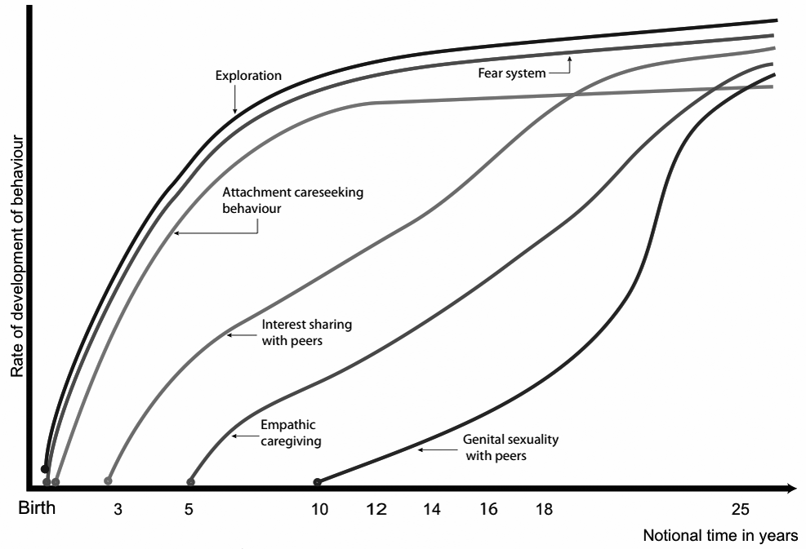
Una McCluskey
ATTACHMENT 159
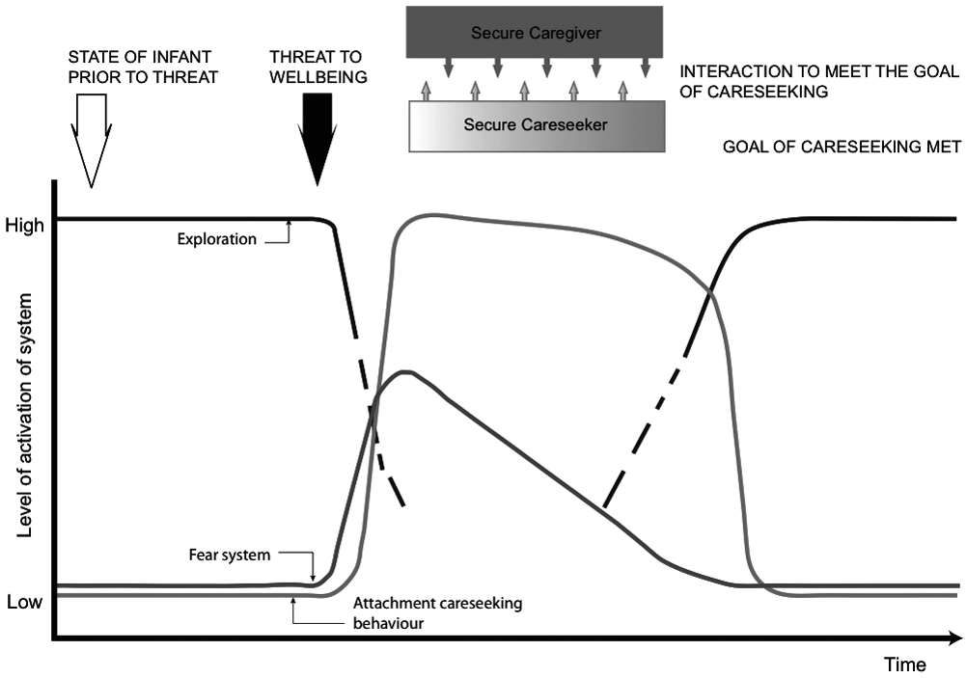
Figure 2: Securely attached infant during restorative process interacting with an effective care-giver.
In this diagram, one can see that in the secure child, his or her exploratory system is working at a well developed level. Before the onset of a threat the child’s fear system and care-seeking system are hardly active. Following the threat, what happens is there is an immediate arousal of fear and care-seeking. However, in the secure child, that child seeks out a care-giver and once they start interacting with them their fear system goes right down. Depending on how much interaction is required with the care-giver, in time, the child returns to their normal exploratory level.
The next diagram, Figure 3 (overleaf), shows an insecurely attached infant responding to a threat to well-being.
The striking thing about this diagram is that prior to the onset of a threat the insecure child’s exploratory level is really quite low. Following the threat, like in the secure child, their fear and care-seeking get activated, but unlike the other child they interact with their care-giver with fear. If the care-giver is unable to see what is happening they could react to the frightened child, who may well be expressing their fear through anger, by becoming defensive them- selves thus leading to unpredictable outcomes.
Fear Free Exploratory Care-giving
160 ATTACHMENT
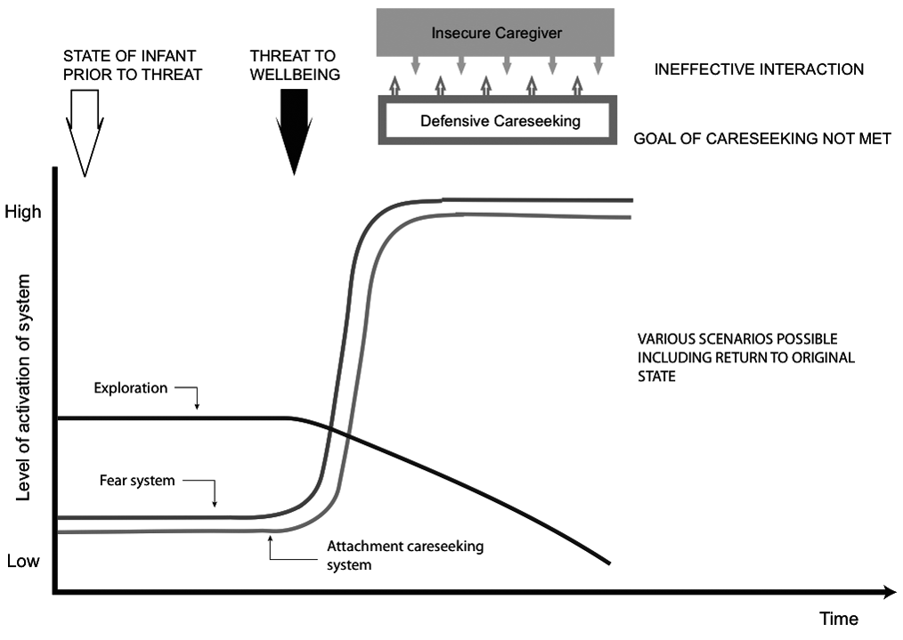
Figure 3: Insecurely attached infant responding to a threat to well-being.
The next diagram, Figure 4, shows a securely attached adult responding to a threat to well-being.
The reader will note that the pattern is similar to that of the secure child. However, with the adult, their capacity for empathy is much more developed and while there is a dip in their capacity for empathy following a threat to the self, they do not lose that capacity completely. This is very different to what happens in the insecure adult and can be examined in the final diagram, Figure 5.
One can see that in the above scenario, the fear system overrides care-seek- ing and in addition they are responded to by a care-giver whose own fear system is overriding care-giving. The care-seeker and care-giver are both distressed, both unregulated, anything could happen.
Working with professional care-givers: an exploration of the dynamics of attachment and exploratory interest sharing
I started this work some years ago but I had no idea how important it would prove to be.
Una McCluskey
ATTACHMENT 161
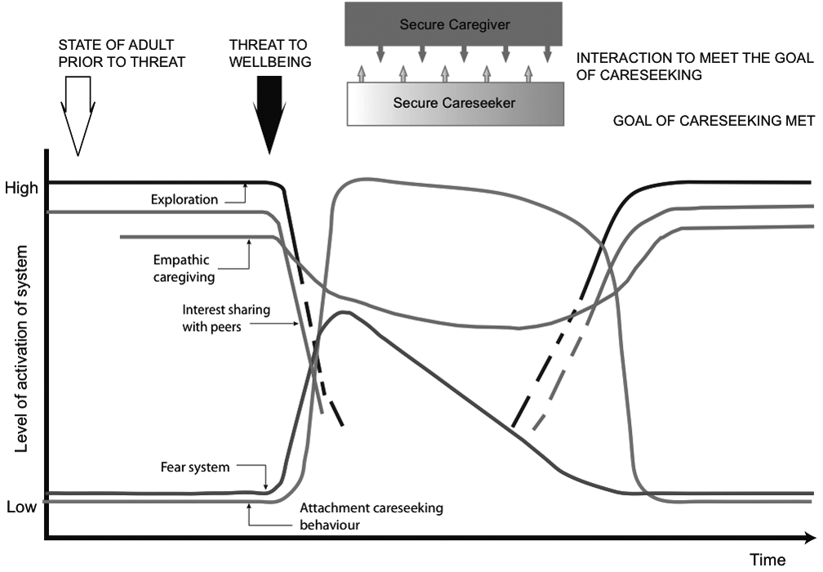
Figure 4: Securely attached adult responding to a threat to well-being.
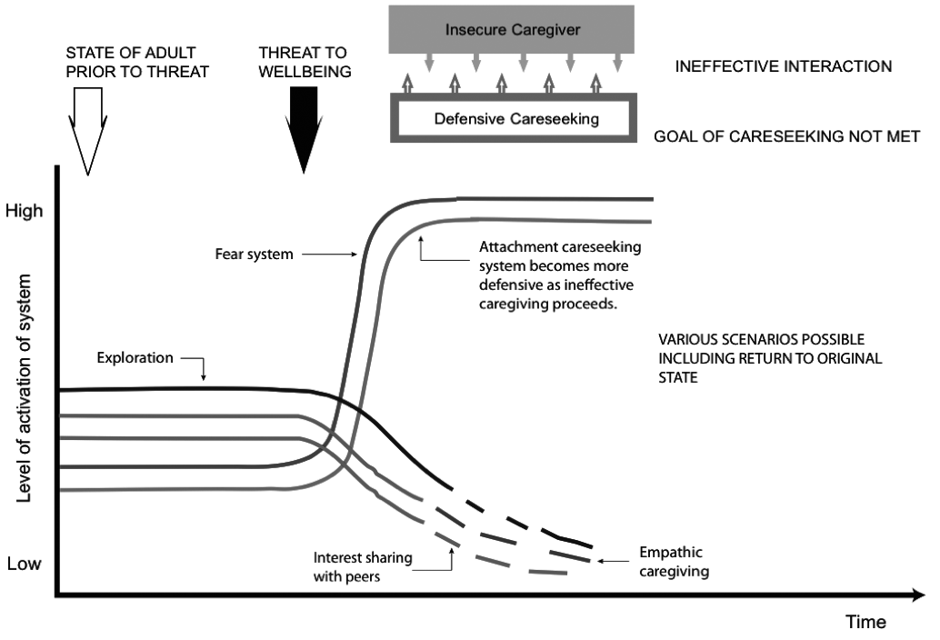
Figure 5: Insecurely attached adult responding to a threat to well-being.
Fear Free Exploratory Care-giving
162 ATTACHMENT
This work is not about identifying attachment patterns, it is an in-depth exploration of what someone knows about what activates care-seeking in the here and now, how they express it and whether they are met. It is about explor- ing the aetiology of this and what people know about their own care-seeking patterns. Whether they are aware of how their own fear system interacts with their care-seeking system. It is about exploring what arouses care-giving and what people know about how that system works within themselves. It is exploring their system for self-defence and whether they are aware which system dominates and determines their behaviour when they face a threat to their well-being, as described earlier in this paper. It is about exploring how, whatever system dominates, following a threat to well-being interpenetrates their internal environment and their systems for care-giving, interest sharing, sexuality, and capacity to create a supportive lifestyle.
So we look at the whole process of how the various systems work together to maintain levels of well-being and whether in fact well-being is restored or not, given the behaviour of the person and the responses of others. It is this understanding that the therapists then bring to their work with clients. So, it is very different indeed to simply naming one’s attachment pattern.
It is helping people to centre in the here and now. To respect the informa- tion they get in their bodies through the process of attuning to the affect of others. Recognising the power of affect attunement, care-givers begin to explore the effect on their own development of attuning to the affect of fearful, frightening, dismissive, or neglectful early care-givers. The work emphasises exploration over interpretation, validates the reality of people’s past and present experience, and focuses on what one can do now to change one’s pattern of care-seeking so that people might get access to more effective care- giving. This is the driver for change.
One of my findings from the groups for professional care-givers is the vast number of people who can identify when their care-giving system was first aroused. What is striking about their memories is that the other system that was aroused in parallel to their care-giving, was the fear system, often aroused in relation to ill, distressed, distracted, dysfuntional, or disturbed parent figures. So we have the arousal of the care-giving system and the arousal of the fear sys- tem, at the same time. Very often the child was attuning to the fear of the adult and trying to regulate the adult as best they could through providing care, but the whole situation, of course, was too big for the child to manage and what got lost was the child themselves, and any awareness by an adult that the child was dysregulated and trying to cope with something that was too much for them.
Since early 2006, I have been working intensively in monthly groups with professional care-givers. To date I have worked with over 400 men and women from a variety of professional backgrounds (McCluskey, 2007, 2008, 2010, 2011), and while I do not have the actual count, this will have to wait for the formal
Una McCluskey
ATTACHMENT 163
research, it is my impression that this is an underlying theme in the lives of the majority of adult care-givers. The work that we have been doing together is recognising this impossible burden, the effect of such a situation on our bodies, the effect it has had on us being able to develop our own interests, and the way in which defensive care-giving has infiltrated many aspects of our lives, not only professional.
So the legacy of Bowlby’s work for the twenty-first century is, in my view, supporting our lay and professional care-givers, providing opportunities for them to expand their consciousness of themselves, to help them to connect with their biological selves, and to help them to become better care-seekers. All of this so that they can grow and develop through their interactions with effective care-givers who can moderate their care-giving, in order to make space for an interest sharing life. Defensive care-giving seems to wipe out any possibility of allowing space for a self to develop, a self that would find itself through exploring its own interests and developing its own life.
We need to support the development of a living process that is operating in the here and now using information from our body to access whether our own fear system has become aroused by feeling threatened by our clients or by the activation of our own unsupported internal environment. We need to regulate that system for ourselves so that we can remain truly exploratory with our clients.
The model that I have developed to do this I have called “exploratory goal- corrected psychotherapy” (EGCP) (McCluskey, 2005). I have given it this rather unwieldy title because I think it accurately describes the nature of this work. The work that I have been describing is to provide an exploratory space where professional care-givers can explore the biological systems within themselves that interact to enable them to maintain as much well-being as possible. The work of the facilitator is to enable the person(s) to identify what system is aroused in the here and now and to interact with them in such a way that the person experiences reaching the goal of that system. In that way, the work for the person is exploring goal-corrected systems and the work of the facilitator is itself goal-corrected. If the facilitator fails to reach the person, misses them, or becomes fearful in response to them, the interaction is not goal-corrected, both remain distressed, and development does not proceed on the basis of core support at the centre of the self, transforming and strengthening the self.
Conclusion
It is sometimes difficult to actually see that children or adults are being emotionally abused when you have been emotionally abused yourself.
It seems to me that the position of being a carer in our society carries enor- mous power. By definition a carer is working with or relating to somebody who is very vulnerable and who cannot do or is unable to do things for themselves.
Fear Free Exploratory Care-giving
164 ATTACHMENT
We need to be able to identify what systems are getting activated in carers who are responsible for the very vulnerable. We know that responses can range from a denial of the other person’s pain to a desire to inflict further pain or an over intrusiveness that is completely unattuned to the state that the other is in. It may include an unwillingness or an inability to regulate the other’s affect and a lack of response to cries and signals for help.
We need to be much more focused on the potential in emotionally unregulated care-givers for sadistic care-giving and the conditions that allow this to flourish. We must support the fragile selves of those who offer to care for others.
When Isabel Menzies Lyth (1960) investigated institutional behaviour she identified that much of it was driven by a defence to ward off anxiety. I feel I have come to the same conclusion but from a different theoretical perspective. The main challenge for us is to help therapists to identify their fear system so that they are able to see the effect of the fear system on their own emotional functioning. As Dorothy Heard said in a conversation with me a few years ago, “it’s not the self that gets aroused, it is the different systems within the self that get aroused.” There is a way in which we can create the conditions so that the carer, the professional care-giver, can monitor the arousal of their own systems therefore becoming more exploratory in relation to themselves and therefore be able to provide truly effective (exploratory) care-giving to their clients.
This paper has highlighted the fact that the systems we put in place to provide care for vulnerable others can themselves become abusive and fright- ening. When this happens, the general reflex attitude in society is to demonise those who have tried to care and insist that what is needed is better monitor- ing and surveillance. We must stop terrorising the carers. We must start supporting those who take on caring roles. Providing intimate care and response to a person who is frightened or distressed is very difficult. This paper has pointed out that it is often the least well equipped who put them- selves forward as carers. We must find ways to support their development and validate the enormous importance of their work.
It is very important that we begin to understand the processes involved in reaching and maintaining a state of well-being. It is the state we aspire to. So in exploratory psychotherapy, the goal is the achievement of the state of well- being and the means by which to maintain it. It is in this state that we feel most ourselves, we feel most alive, most creative, most in touch with the here and now, the physical and spiritual realities of now. We have a sense of our own vitality and our own capacity to become co-creators with life itself.
Acknowledgement
The diagrams in this paper were created by, and are the property of, Dorothy Heard and Brian Lake.
Una McCluskey
ATTACHMENT 165
References
Ainsworth, M. D. S., & Wittig, B. A. (1969). Attachment and the exploratory behaviour of one-year-olds in a strange situation. In: B. M. Foss (Ed.), Determinants of Infant Behaviour (Vol. 4) (pp. 113–136). London: Methuen.
Ainsworth, M. D. S., Bell, S. M., & Stayton, D. (1974). Infant-mother attachment and social development. In: M. P. Richards (Ed.), The Introduction of the Child into a Social World (pp. 99–135). London: Cambridge University Press.
Ainsworth, M. D. S., Blehar, M. C., Waters, E., & Wall, S. (1978). Patterns of Attachment: A Psychological Study of the Strange Situation. Hillsdale, NJ: Erlbaum Associates.
Bowlby, J. (1969). Attachment and Loss (Vol. 1, Attachment). London: Hogarth. Bowlby, J. (1979). Self-reliance and some conditions that promote it. In: The Making
and Breaking of Affectional Bonds. London: Tavistock.
Emde, R. N. (1983). The pre-representational self and its affective core. Psychoanalytic
Study of the Child, 38: 165–192.
Emde, R. N. (1985). An adaptive view of infants emotions: functions for self and know-
ing. Social Sciences Information, 24: 237–341.
Goffman, E. (1961). Asylums: Essays on the Social Situation of Mental Patients and
Other Inmates. Anchor, NY: Doubleday.
Grossmann, K., Fremmer-Bombik, E., Rudolph, J., & Grossmann, K. E. (1988).
Maternal attachment representations as related to child-mother attachment pat- terns and maternal sensitivity and acceptance of her infant. In: R. A. Hinde & J. Stevenson-Hinde (Eds.), Relations Within Families. Oxford: Oxford University Press.
Grossmann, K., Grossmann, K. E., Spangler, G., Suess, G., & Unzner, L. (1985). Maternal sensitivity and newborns’ orientation responses as related to quality of attachment in northern Germany. Growing Points in Attachment Theory and Research. Monographs of the Society for Research in Child Development, 50: 233–278.
Heard, D. H., Lake, B., & McCluskey, U. (2009). Attachment Therapy with Adolescents and Adults: Theory and Practice Post Bowlby. London: Karnac.
Humphries, S. (1998). TV Programme, Sex in a Cold Climate, directed by Steve Humphries. Testimony Films, Channel 4 Television Corporation. www.vimeo. com/13158888
Le Doux, J. (1998). The Emotional Brain. London: Weinfield and Nicholson.
Lentin, L. (1995). Film, Dear Daughter, directed by Louis Lentin. Available from Crescendo Concepts, 88 Leinster Road, Dublin 6. http://www.iftn.ie/filmography/ ?act1=record&aid=70&rid=1853&sr=1&only=1&hl=dear+daughter&tpl=
filmography_dets
Lintern, S. (2102). Health Service Journal, 22 November 2012.
McCluskey, U. (2000). Abuse in religious institutions. In: U. McCluskey & C. A. Hooper
(Eds.), The Psychodynamics of Abuse: The Cost of Fear (pp. 100–117). London:
Jessica Kingsley.
McCluskey, U. (2005). To Be Met as a Person: The Dynamics of Attachment in
Therapeutic Encounters. London: Karnac.
Fear Free Exploratory Care-giving

